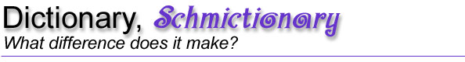

Checklist for your memo:

- My memo has a tone and diction (choice of words) appropriate for the audience, the principal.
- My recommendation is clear.
- My memo includes specific reasons and examples to support my recommendation.
- My memo contains vivid language.
- I have checked my writing for clarity and mechanics.
- I have edited and proofread my memo and checked for these:
  - spelling
  - capitalization
  - punctuation
  - paragraphing
- I have revised my memo so that my voice comes through appropriately.
- My memo has correct grammar, a variety of sentence types, and effective paragraph structure.
- My memo observes correct manuscript conventions:
  - one-inch margins on all 4 sides
  - a standard, 12-point font (no bold, italic, or fancy fonts)
  - correct memo format

